- Deploy a Static Website on AWS
- Deploying a static website on AWS is a practical way to understand cloud services. Here's a step-by-step guide to help you create and deploy a static website using Amazon S3, with optional CloudFront for CDN and Route 53 for custom domains.

- Step-by-Step: Deploy a Static Website on AWS
- Prerequisites
- An AWS account
- A static website (HTML/CSS/JS files) ready to deploy

- Step 1: Create an S3 Bucket
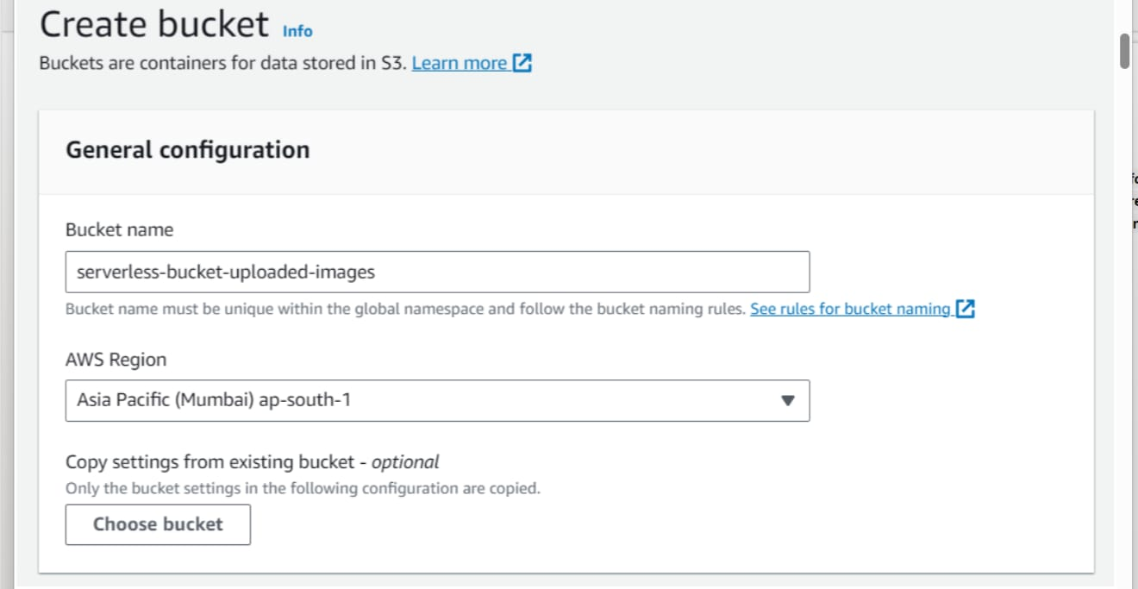
- 1. Go to the AWS Management Console
- 2. Navigate to S3
- 3. Click "Create bucket"
- 4. Set a unique bucket name (e.g., staticwebsite12)
- 5. Uncheck “Block all public access” under permissions
- 6. Acknowledge the warning and create the bucket
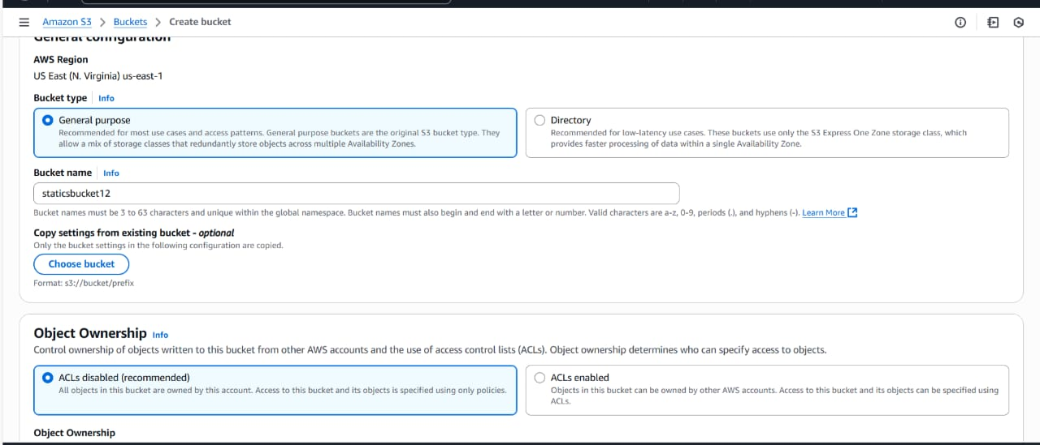

Step 2: Upload Website Files
- 1. Click on your bucket
- 2. Click Upload → Add files/folders
- 3. Upload your HTML, CSS, JS, and media files
- 4. Click Upload

Step 3: Configure Bucket for Static Website Hosting
- 1. go to Properties tab
- 2. Scroll to Static website hosting
- 3. Click Edit
- 4. Enable it and specify:
- 5. Index document: index.html
- Error document: error.html (optional)
- Save changes

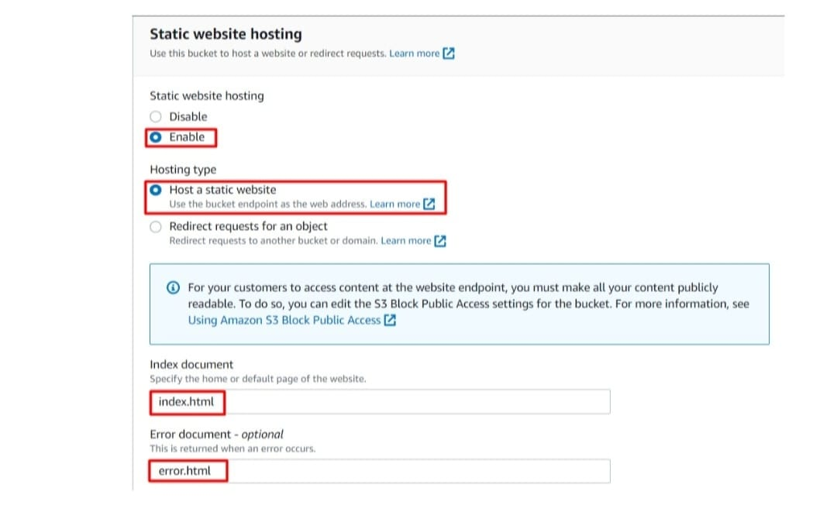

Step 4: Make Files Public
- 1. Select all files in the bucket
- 2. Click Actions → Make public (or set permissions manually using bucket policy)
Example Bucket Policy
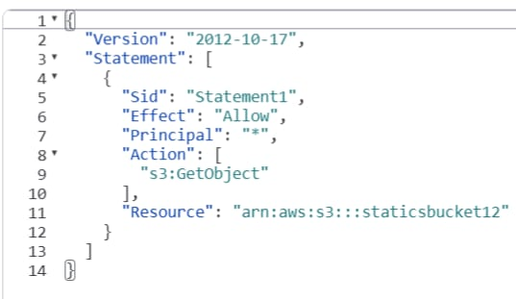

Replace my-static-site with your actual bucket name.

Step 5:Access Your Website
- Go to Properties → Static website hosting
- Use the Endpoint URL provided to view your live site

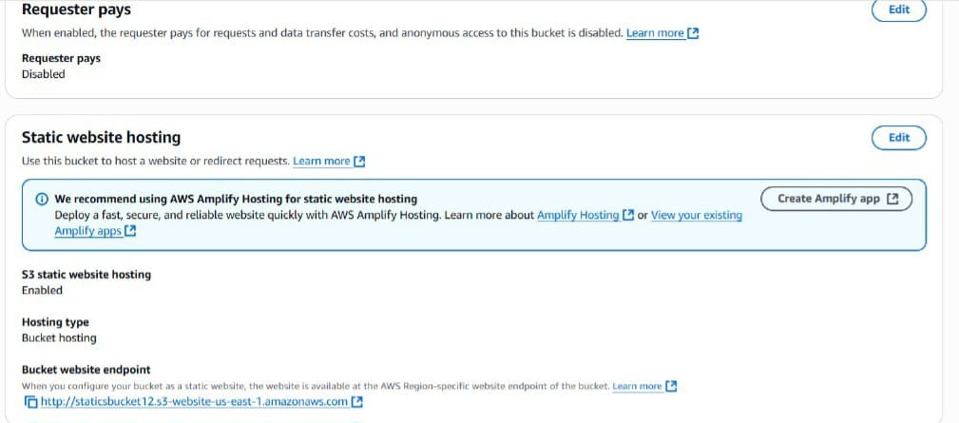
Step 6: Use a Custom Domain with Route 53 and CloudFront
- 1. Register a domain (or use an existing one)
- 2. Create a CloudFront distribution
- Set S3 bucket as origin
- Enable "Redirect HTTP to HTTPS"
- Add custom domain under “Alternate domain names”
- 3. Set up SSL using AWS Certificate Manager (ACM)
- 4. Use Route 53 to point your domain to CloudFront

